1️⃣1️⃣ HTML BLOCK & INLINE ELEMENTS
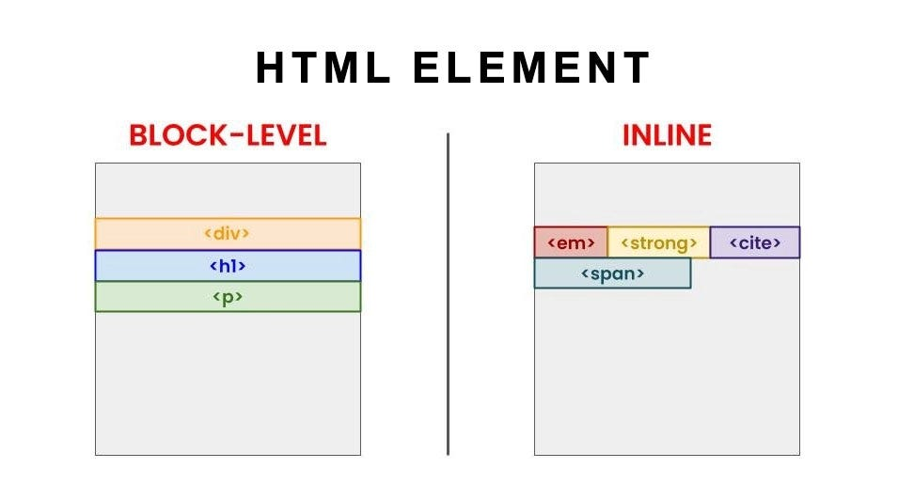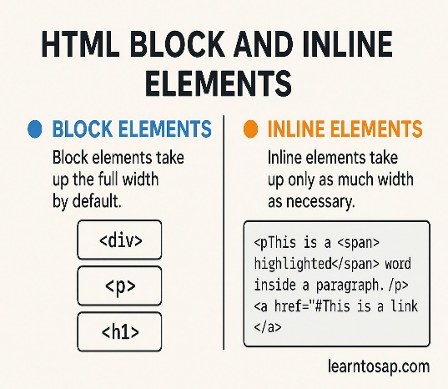
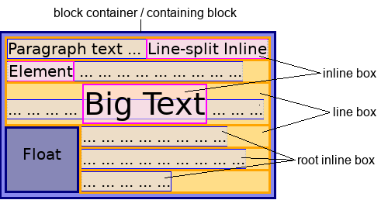

🔹 Block Elements
Block elements:
- Start on a new line
- Take full available width
Examples:
<div>Block</div>
<p>Paragraph</p>
<h1>Heading</h1>
📌 Common block elements:
<div>, <p>, <h1>–<h6>, <section>, <article>

🔹 Inline Elements
Inline elements:
- Stay in the same line
- Take only required width
Examples:
<span>Inline</span>
<a href="#">Link</a>
<img src="img.png">
📌 Common inline elements:
<span>, <a>, <img>, <strong>, <em>

🔹 Difference (Interview Favorite 🔥)
Block | Inline
New line | Same line
Full width | Content width
Layout building | Text formatting
📌 CSS can change behavior
display: block; / display: inline;

1️⃣2️⃣ HTML DIV & SPAN
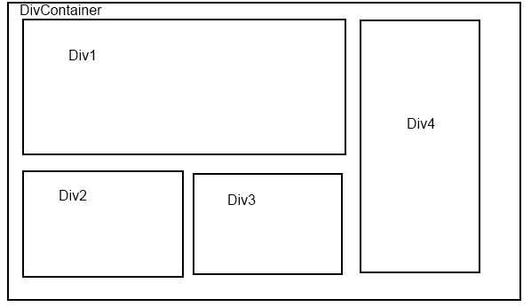

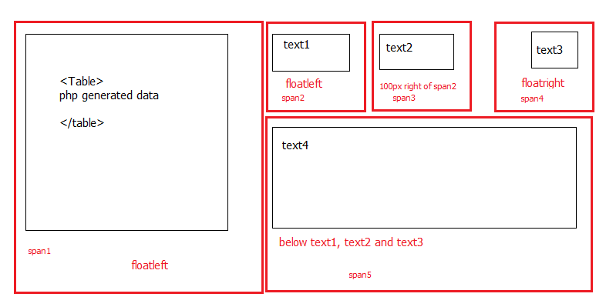
Used for layout and grouping.
🔹 <div> – Block Container
<div class="card">
Content here
</div>
✔ Used for sections, layouts, wrappers
✔ Takes full width

🔹 <span> – Inline Container
<p>This is <span style="color:red;">important</span></p>
✔ Used for small inline styling
✔ Does not break line

📌 Real-World Analogy (Students love this 🔥)
div = room
span = sticker inside the room

1️⃣3️⃣ HTML CLASSES & ID
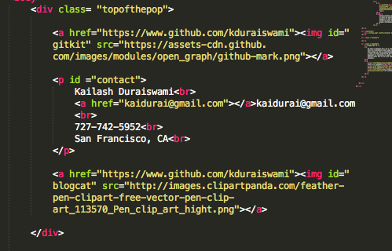

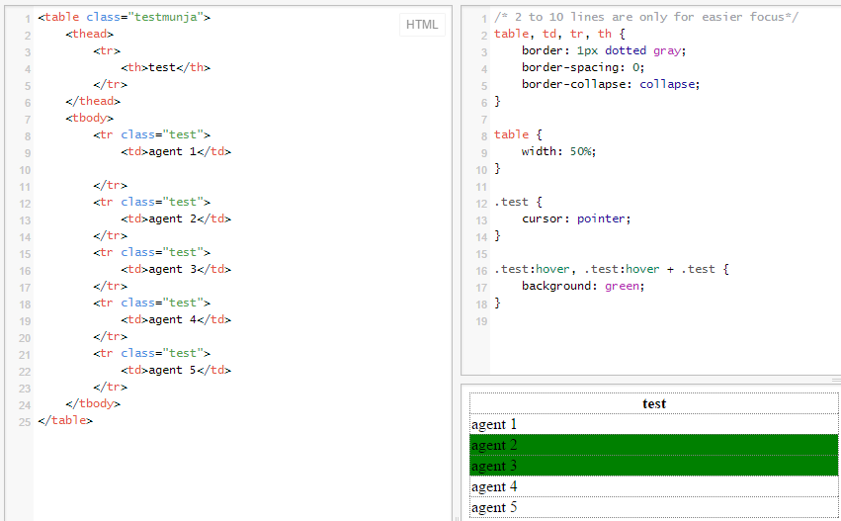
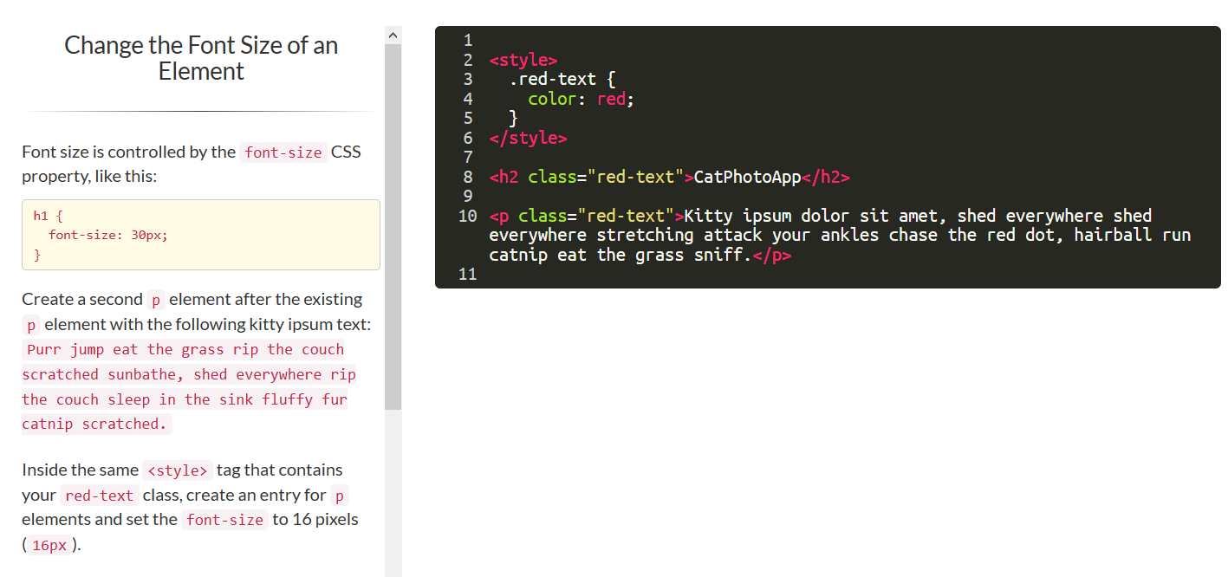
Used with CSS & JavaScript for styling and DOM access.

🔹 class (Reusable)
<div class="box"></div>
<div class="box"></div>
✔ Multiple elements
✔ Used for styling groups

🔹 id (Unique)
<div id="header"></div>
✔ Only one element
✔ Used for JS & anchors

🔹 Difference Table
class | id
Multiple elements | Single element
Reusable | Unique
CSS styling | JS targeting
📌 Golden Rule:
❌ Never repeat the same id

1️⃣4️⃣ HTML FORMS
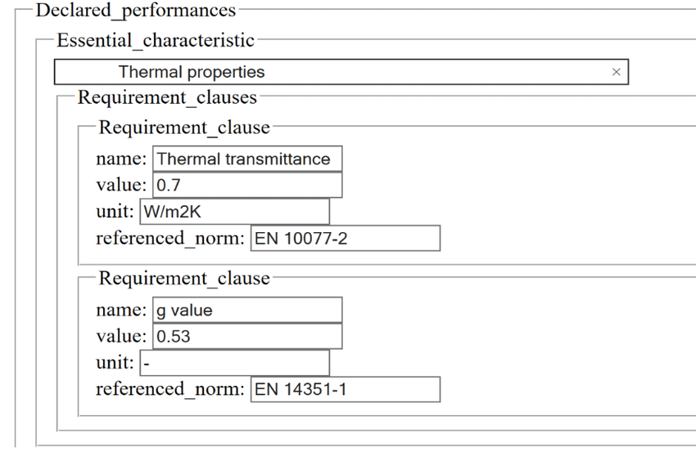
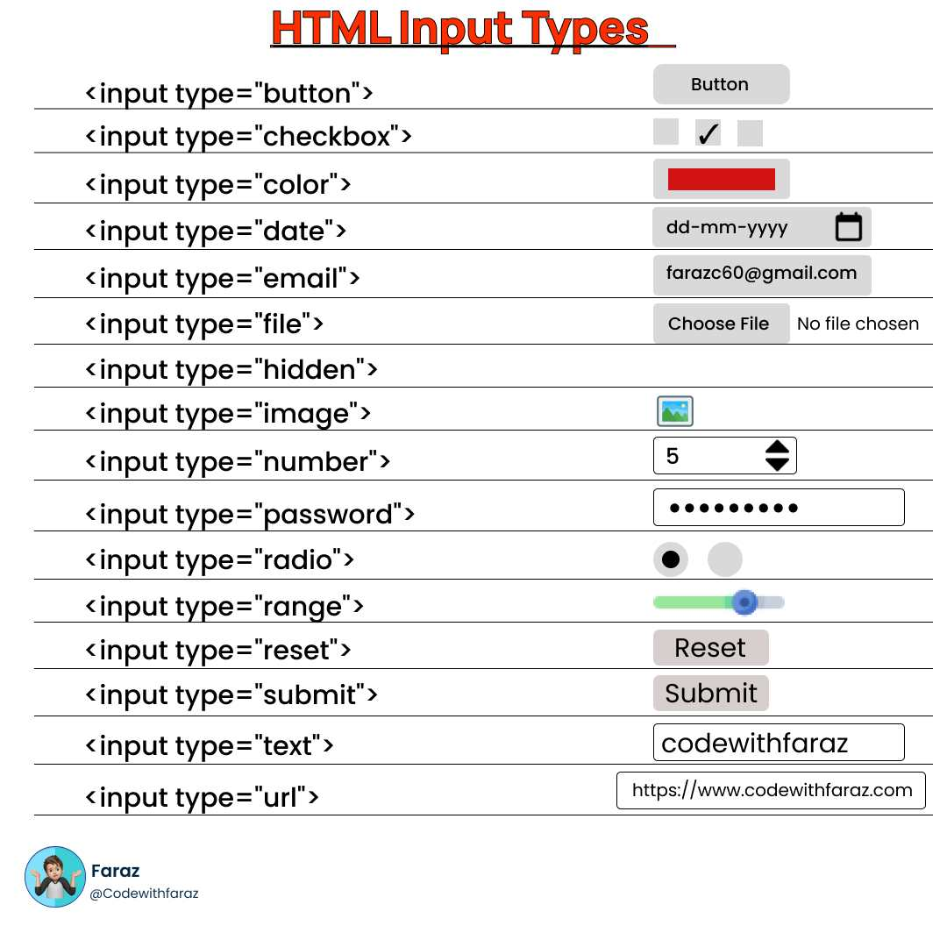
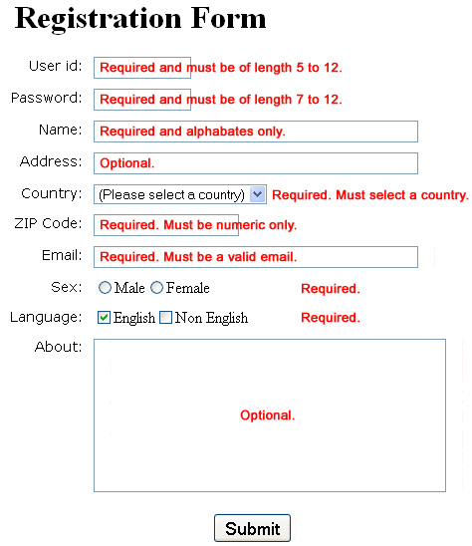
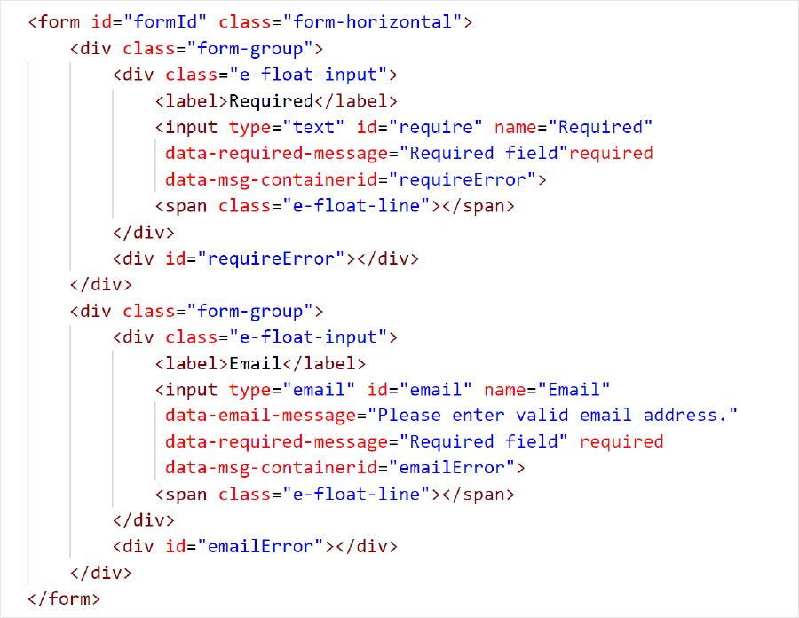
Forms are used to collect user input.

🔹 Basic Form
<form>
<label>Name</label>
<input type="text">
<button>Submit</button>
</form>

🔹 Form Tags
Tag | Purpose
<form> | Form container
<input> | Input field
<label> | Field label
<textarea> | Multi-line input
<select> | Dropdown
<option> | Dropdown value
<button> | Action
<fieldset> | Group fields
<legend> | Group title

🔹 Input Types (VERY IMPORTANT 🔥)
Type | Use
text | Name
password | Secure input
email | Email validation
number | Numeric input
radio | Single choice
checkbox | Multiple choice
file | Upload
date | Calendar
color | Color picker
range | Slider
submit | Submit form
reset | Reset form
📌 Browser validates email automatically (Interview 🔥)

1️⃣5️⃣ HTML IFRAME
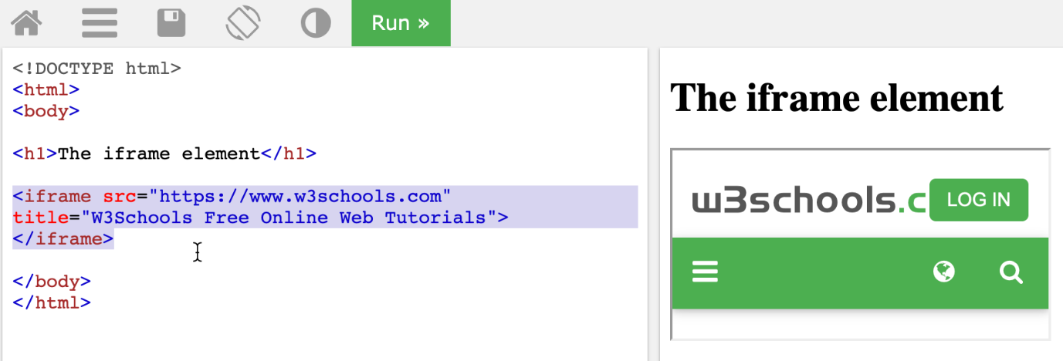
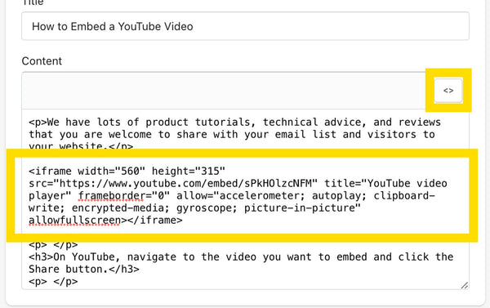
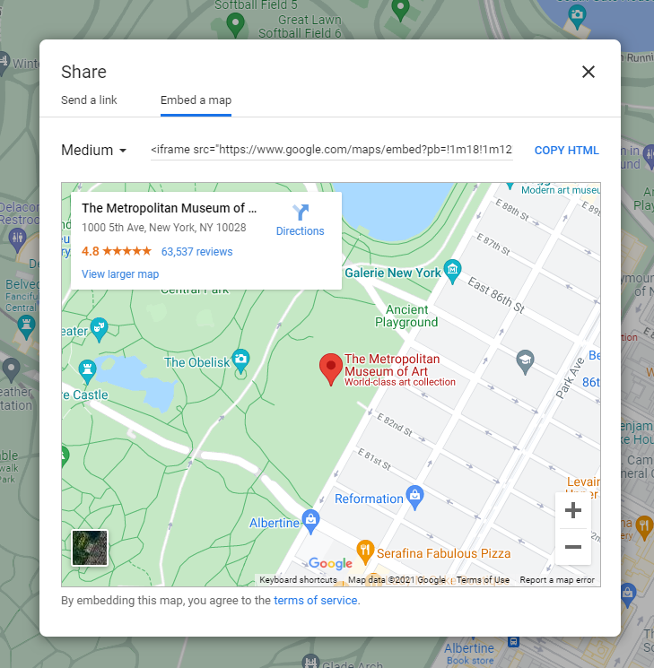
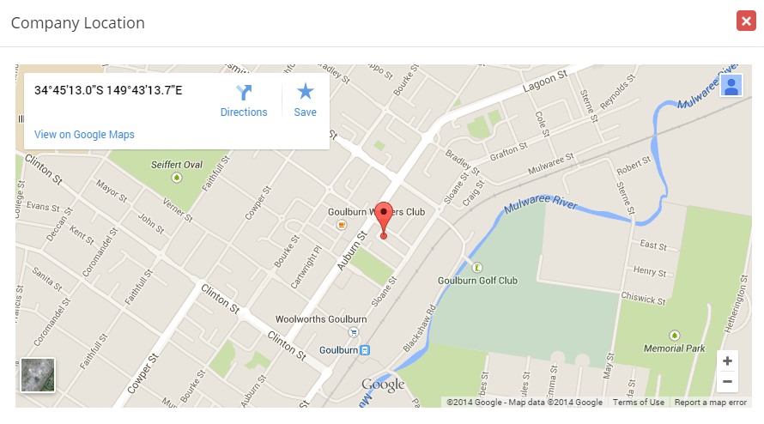
Used to embed external pages inside your website.

🔹 Basic Iframe
<iframe src="https://example.com"></iframe>

🔹 YouTube Embed
<iframe src="https://www.youtube.com/embed/videoID"></iframe>

🔹 Google Maps Embed
<iframe src="https://maps.google.com"></iframe>

📌 Important Notes
✔ iframe loads another webpage
✔ Can be blocked by security policies
✔ Use sandbox for safety
📌 Interview Line:
iframes are powerful but must be used carefully due to security.

